Contents
Context 1
A note on naming conventions 2
Viewing a shared dataset 3
Visual Studio 3
HR Reporting environments 5
Creating a new shared dataset 6
Create the .RSD file 6
Attach the dataset to an .RDL 7
Attach the dataset to a parameter 8
Deploy the new dataset 9
Editing a shared dataset 10
Amend the .RSD file 11
Update the dataset properties 11
Retiring a shared dataset 14
Make a note of Dependent Items 14
Remove the dataset from an .RDL 14
Remove the dataset from a parameter 15
Remove the dataset from HR Reporting 16

Additional Guidance
Knowledge Article: not yet written
HOW TO - Manage Reports - Access Permissions within HR Reporting.docx
HOW TO - Manage Reports - Change Processes in OSM.docx
HOW TO - Manage Reports - HR Reporting Environments.docx
HOW TO - Manage Reports - Parameters.docx
HOW TO - Manage Reports - Release and Deployment.docx
HOW TO - Manage Reports - Shared Data Sources.docx
HOW TO - Manage Reports - Troubleshoot Common Errors.docx
HOW TO - Manage Reports - Visual Studio Basics.docx

Context
Shared datasets are SQL queries which are available to re-use across multiple report (.RDL) files. In HR Reporting, shared datasets are used to retrieve reference data from PeopleXD, in order to populate drop-down lists for report parameters.

- Example: Many reports have a “Department” parameter, which allows users to specify which department(s) they want to see returned in the report results. It looks like this:
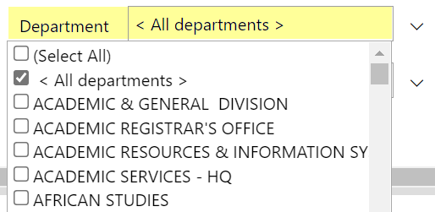

- The shared dataset LOV_Optional_Department.rsd is the source of information for the “Department” parameter’s drop-down list. The shared dataset queries PeopleXD’s database and returns a list of all active departments. This list is then attached to the “Department” parameter, so that users can select the departments in which they are interested.
Because LOV_Optional_Department.rsd is a shared dataset, it can be attached to any report which has a “Department” parameter.

Shared datasets are managed in two places: Visual Studio, where they are created and amended, and the HR Reporting environments, where they are deployed to run alongside reports. See below for detailed guidance.

A note on naming conventions
All shared datasets are prefixed with the phrase “LOV_Optional”, because shared datasets return lists of values (LOVs) from which users can select the options in which they are interested. Shared datasets must adhere to the following naming conventions to make it easy to identify what sort of data a given dataset might return.

- If the dataset returns reference codes, the convention is:
LOV_Optional + Reference item_Code
- If the dataset returns reference descriptions, the convention is:
LOV_Optional_Reference item
- If the dataset returns reference codes and descriptions, the convention is:
LOV_Optional + Reference item +_and_Description

Some examples are given here.

What is retrieved? | Shared dataset name
List of department codes | LOV_Optional_Department_Code
List of department names | LOV_Optional_Department
List of department codes + names | LOV_Optional_Department_and_Description
List of absence reason codes | LOV_Optional_AbsenceReason_Code
List of absence reasons | LOV_Optional_AbsenceReason
List of absence reason codes + descriptions | LOV_Optional_AbsenceReason_and_Description

Viewing a shared dataset

Visual Studio
Shared datasets are created and amended in Visual Studio, where they are saved with file extension .RSD. You can view a complete list of the shared dataset files in your current Visual Studio solution (.sln) by going to the Solution Explorer pane and expanding the Shared Datasets folder:

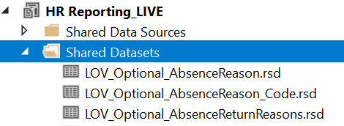

The data a shared dataset retrieves from PeopleXD is defined within the SQL query of that dataset. You can view the SQL query at any time by opening the .RSD file, either by double-clicking it, or right-clicking and selecting Open from the menu:

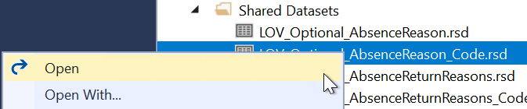

The Shared Dataset Properties window will open.

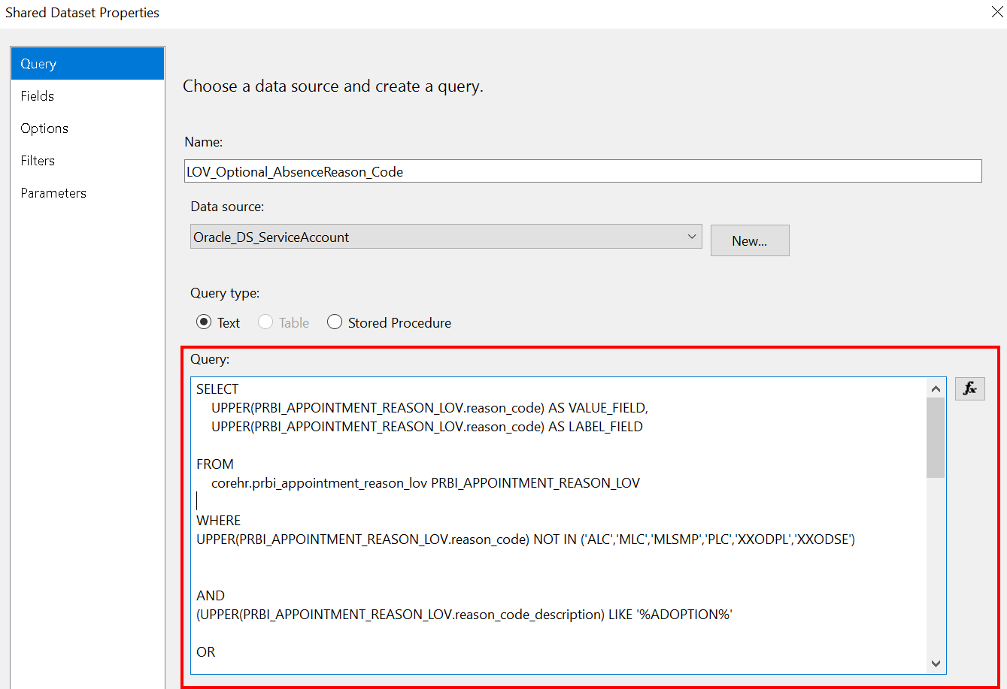

All shared datasets have the following properties:

- Name – the name of the dataset .RSD file (this must follow the naming conventions outlined above).
- Data source – the shared data source for the dataset. This should always be Oracle_DS_ServiceAccount.
- Query type – this should always be “Text”.
- Query – this is where the SQL query for the dataset is stored. The query code defines what information the shared dataset will retrieve from PeopleXD.

The Query pane is displayed in the lower half of the Shared Dataset Properties window:



You can preview the data a shared dataset will retrieve by clicking “Query Designer…” at the bottom of the Query pane:
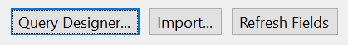

The Query Designer window will open. Click the “Run” button (!) at the top of the screen to preview the shared dataset – this triggers the SQL query to contact the PeopleXD database and retrieve information:

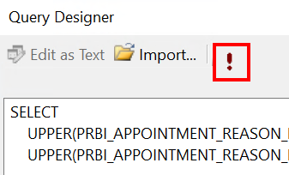

The SQL query will run and the results will be displayed in the lower half of the Query Designer window:

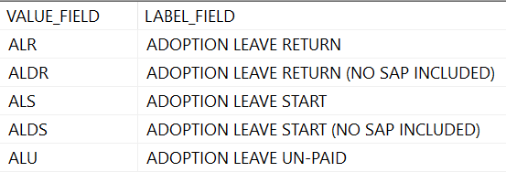

HR Reporting environments
A shared dataset (.RSD) is like a report (.RDL): both run SQL code which queries the PeopleXD database to retrieve information. Just like reports, shared datasets need to be deployed from Visual Studio to the HR Reporting environments so that users can run the queries.

 | NB: Always remember to deploy your shared datasets to the HR Reporting environments!  If a shared dataset does not exist in an HR Reporting environment, it won’t be able to populate drop-down lists for any report parameters which depend on that dataset.  For example, if a report has a parameter for “Department Code”, the shared dataset which retrieves the list of department codes from PeopleXD must exist in the HR Reporting environment, or the parameter will not work.

You can view a complete list of the shared datasets in any HR Reporting environment by navigating to Home → Datasets (MASTER) within the environment:

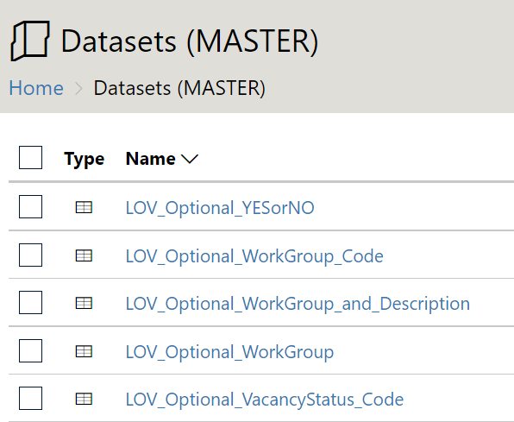

 | Datasets (MASTER) is a hidden folder in the HR Reporting environments. You may need to tick the “Show hidden items” option on the Home screen before you’ll see it! | 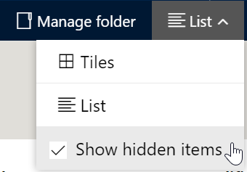

Click on a shared dataset to be taken to its Properties page. Here, you can view the dataset’s name and data source, the security applied to the dataset, and (most importantly) which reports depend on the dataset.
Reports which are linked to a shared dataset are called that dataset’s “dependent items”. Click the Dependent items link in the properties menu to see a full list of all the reports which rely on the shared dataset. In this example, you can see that the shared dataset has 337 dependent items:

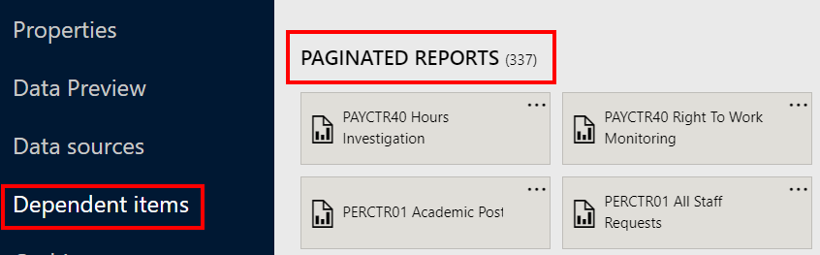

Any changes to this shared dataset will affect all 337 dependent items. Information about how to update a shared dataset within the HR Reporting environments is provided below.

Creating a new shared dataset

Create the .RSD file
To create a new shared dataset, go to the Solution Explorer pane and right-click the Shared Datasets folder and select “Add New Dataset”:

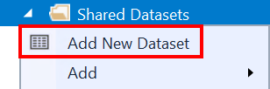

The Shared Dataset Properties window will open. You must now set the following properties for your new dataset:

- Name – LOV_Optional_... (see the note on naming conventions)
- Data source – Oracle_DS_ServiceAccount
- Query type – Text
- Query – this is where you must paste the SQL query for your shared dataset.

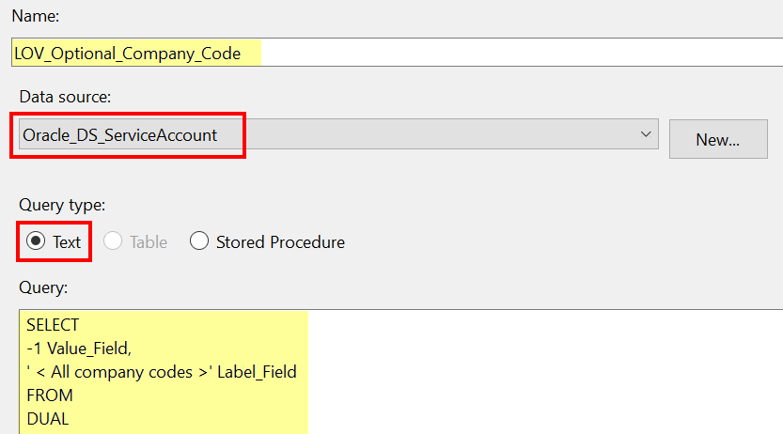

You can preview your new dataset by clicking “Query Designer…” to open the Query Designer window:



Click the “Run” button (!) at the top of the screen to preview the dataset results. To save your new dataset, enter CTRL + S. The new dataset will be saved to your current Visual Studio solution, and you can now add it to report .RDL files to populate LOV parameters.

Attach the dataset to an .RDL
Once you’ve created the .RSD file, you will need to attach it to the relevant report .RDL file(s).

- Example: Your report .RDL file has a parameter for “Employee Status” and you want it to display a list of all Employee Status values, so that when a user runs the report, they can choose which employee statuses they want to filter the report for (e.g. only PERMANENT and FIXED TERM employees).
You have created a new shared dataset called LOV_Optional_EmployeeStatus.rsd to query PeopleXD’s database and return a list of all active employee statuses. You now need to attach the LOV_Optional_EmployeeStatus.rsd to your report .RDL file to populate the drop-down list for the “Employee Status” parameter.

Open the .RDL file to which you want to attach your new dataset. In the Report Data pane, right-click the Datasets folder and select “Add Dataset…”:

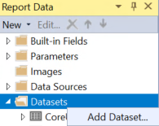

The Dataset Properties window will open. Enter the dataset’s name and select the option to “Use a shared dataset”, then choose your newly-created shared dataset from the list of shared datasets in the lower half of the window:

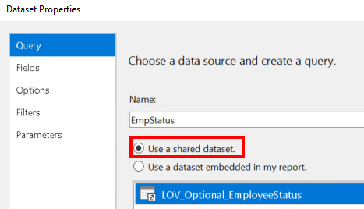

 | When adding a shared dataset to an .RDL file, you don’t need to enter the full formal LOV_Optional… name of the dataset (although you can if you prefer!) Instead, you can just enter a short name for the dataset which refers to the data it is returning, e.g. “EmpStatus” for the LOV_Optional_EmployeeStatus dataset.

Click OK to close the Dataset Properties window. Your new dataset will now appear in the Datasets folder of the Report Pane. Enter CTRL+S to save your changes to the .RDL file.

Attach the dataset to a parameter
Now that your shared dataset is attached to the .RDL file, you must attach it to the specific report parameter which relies on the dataset to populate its drop-down list of values.

In the Report Data pane, expand the Parameters folder. All the parameters contained within the report’s SQL query should be listed here. Select the parameter to which you want to attach your new shared dataset:

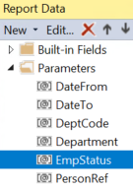
Double-click to open the Report Parameter Properties window. Click into the “Available Values” tab and select the option to “Get values from a query”:

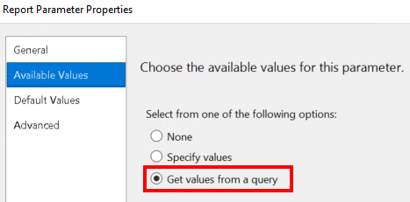

In the lower half of the screen, use the drop-down menus as indicated.

- Dataset: choose your shared dataset.
  - The name displayed here will be whatever you put in the Dataset Properties window from the previous step.
- Value field: select ‘VALUE_FIELD’.
- Label field: select ‘LABEL_FIELD’.

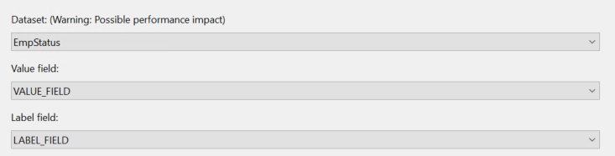

Click OK to close the Report Parameter Properties window, and enter CTRL+S to save your changes to the .RDL file.

Deploy the new dataset
Now that your new shared dataset is attached to the appropriate parameter(s) within the relevant .RDL file(s), you need to deploy the dataset to the HR Reporting environments.

 | Always deploy new shared datasets to all four HR Reporting environments: DEV, TEST, QA and LIVE. This ensures that each environment has all the same shared datasets.  Why is this important?  The QA and LIVE environments must be kept in sync, because QA is a mirror of LIVE, so anything you deploy to LIVE must also go into QA.  The DEV and TEST environments are used for developing and testing reports, so it’s important that they have all the same shared datasets as the LIVE environment, to facilitate testing and development.

To deploy a dataset, go to the Solution Explorer pane and expand the Shared Datasets folder. Right-click on the dataset you need to deploy and select “Deploy”:

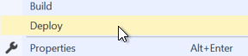

You can see the progress of the deployment in the Output pane at the bottom of the screen:

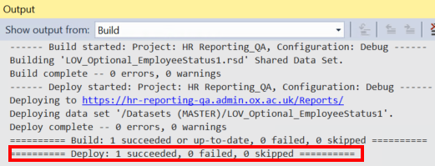

Editing a shared dataset
Generally speaking, you shouldn’t need to make changes to shared datasets, because they are set up to return data from reference tables within the database – this means that any changes made in the database should automatically be reflected in the shared dataset.

- Example: The LOV_Optional_Department dataset is programmed to return a list of all department names from PeopleXD. Whenever a new department is added to PeopleXD, it automatically appears in the shared dataset – you don’t need to do anything to make this happen.

Some shared datasets, however, have hard-coded values or filtered results which may need occasional tweaking.

- Example: The LOV_Optional_AbsenceReason dataset is programmed to return a list of absence-related appointment reasons from PeopleXD. The SQL query for this dataset specifies that only appointment reasons which meet certain conditions should be returned, e.g. when the reason includes the term ‘ADOPTION’ or ‘SICKNESS’. If a new absence-related appointment reason is added to PeopleXD, you will need to hard-code it into the shared dataset!

If you do need to edit a shared dataset, you’ll have to do three things:

- Raise a Change Request on OSM to cover the changes you’re making.
- Amend the .RSD file in Visual Studio with the updated SQL code.
- Update the dataset’s properties within the HR Reporting environments.

See below for guidance.

Amend the .RSD file
Open the relevant solution file in Visual Studio, go to the Solution Explorer pane and expand the Shared Datasets folder. Select the dataset you need to edit, and double-click to open the Shared Dataset Properties window.

Edit the SQL code for the dataset in the Query pane, then click “Query Designer…” at the bottom of the pane to preview your changes:


The Query Designer window will open. Click the “Run” button (!) at the top of the screen to preview the shared dataset:



Once you’re happy with your edits, enter CTRL+S to save your changes to the .RSD file.

Update the dataset properties
Once you’ve saved your changes to your amended .RSD file, you are ready to update the shared dataset in the HR Reporting environments.

 | NB: Do not deploy the amended .RSD file to the HR Reporting environments! This will overwrite the existing shared dataset, and break the link between the shared dataset and all of its “dependent items” (linked reports).  Follow the guidance below for information on how to update the HR Reporting environments so that they use the amended shared dataset.

First, while still within Visual Studio, go to the Solution Explorer pane and expanding the Shared Datasets folder. Click on your amended .RSD file in the list of shared datasets, then go to the Properties pane (beneath the Solution Explorer pane) and copy the “Full Path” field:

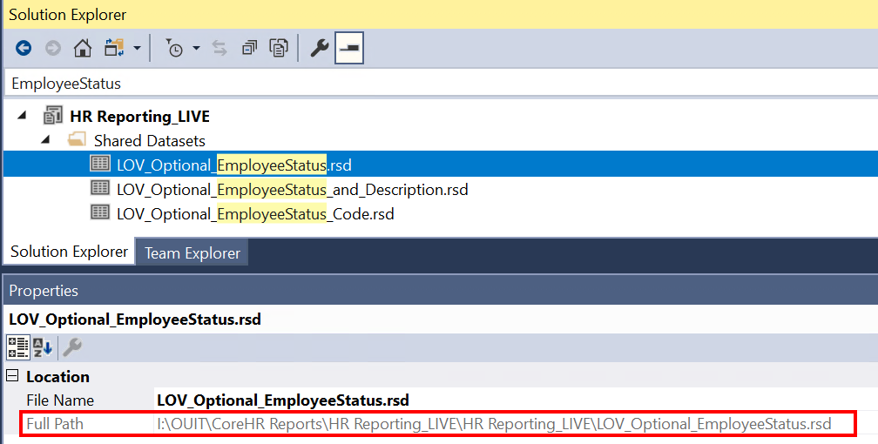

Now navigate to the Home → Datasets (MASTER) within the HR Reporting environment where you want to update the shared dataset:

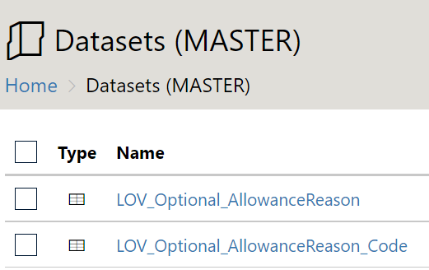

Click on the name of your shared dataset to be taken to its Properties page. At the top of the screen, click the “Replace” button:

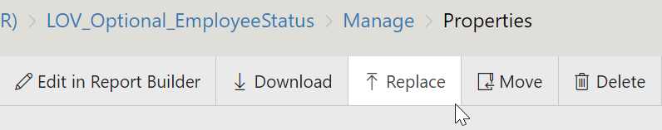

A pop-up window will open. In the “File name” field, enter the full path that you copied from Visual Studio:

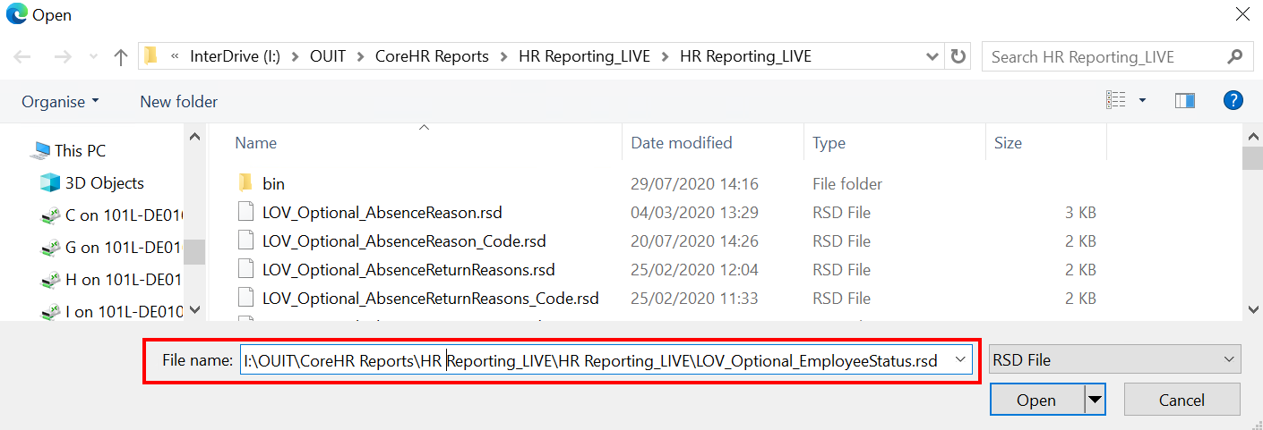

Click “Open” to load the .RSD file into the HR Reporting environment directly from the Visual Studio solution folder. A little pop-up will appear saying “Upload complete”. You may need to click “Apply” at the bottom of the Properties screen to save your changes.
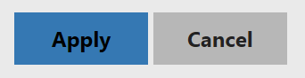

To test that your updated dataset is working correctly, click the Dependent items link in the properties menu to see a full list of all the reports which rely on the shared dataset. Open one of the reports and go to the parameter within that report which uses the shared dataset to check that the parameter displays the correct list of values, and performs appropriately within the context of the report.

- Example: If you have updated LOV_Optional_EmployeeStatus.rsd, click on any of the reports listed on the Dependent items screen:

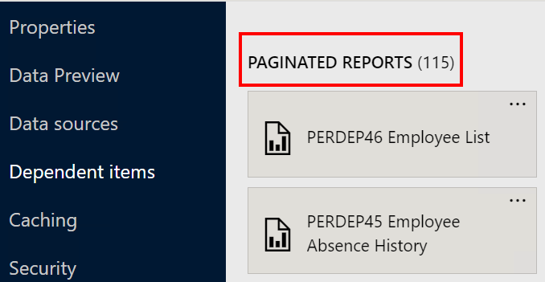

- Within the report, go to the Employee Status parameter and check the list of values in the drop-down menu. Check that the LOV displays the correct values, based on the update you just made:

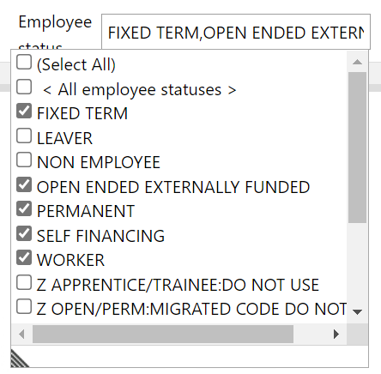

- Select some values from the parameter and run the report query. Check that the report returns the correct results based on the parameters you’ve set.

Make sure you’re satisfied that the updated dataset is performing correctly before closing any OSM change record related to the update.

Retiring a shared dataset
 | It is very, very unlikely that you will ever need to retire a shared dataset, so carefully consider whether this is the correct course of action before you proceed.

If you do need to retire a shared dataset, you will need to do a few things:

- Remove the dataset from the HR Reporting environments.
- Remove the dataset from every .RDL file to which it is currently attached.
- Republish the amended .RDL files without the shared dataset.

Make a note of Dependent Items
Navigate to the Home → Datasets (MASTER) within the HR Reporting environment from which you want to remove the shared dataset:



Click on the name of your shared dataset to be taken to its Properties page. Click the Dependent items link in the properties menu to see a full list of all the reports which rely on the shared dataset.

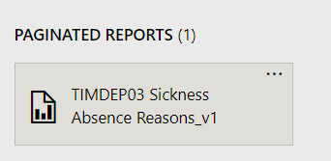

You will need to note each of these reports down in a list so that you know which .RDL files you will need to edit within Visual Studio.

Remove the dataset from an .RDL
Open the relevant Visual Studio solution (e.g. if you are removing a dataset from the DEV environment, open the HR Reporting_DEV.sln). Go to the Solution Explorer pane and locate the .RDL you wish to edit in the Reports folder.

Open the .RDL file. In the Report Data pane, open the Datasets folder and select the dataset you want to remove. Right-click it and select “Delete” to remove it from the .RDL file:

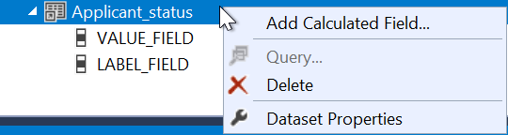

A warning message will pop up. Click “OK”.

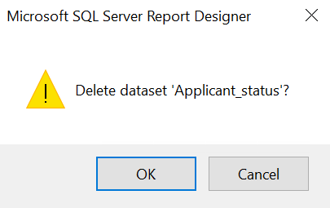

The dataset will be deleted from the .RDL file.

Remove the dataset from a parameter
Now that your shared dataset has been removed from the .RDL file, you must remove it from the specific report parameter which relied on the dataset to populate its drop-down list of values.

In the Report Data pane, expand the Parameters folder. All the parameters contained within the report’s SQL query should be listed here. Select the parameter from which you want to remove your retired dataset:

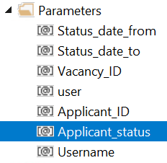

Double-click to open the Report Parameter Properties window. Click into the “Available Values” tab and select the option to “Get values from a query”:



In the lower half of the screen, check that the drop-down menus are blank (i.e. they don’t refer to any dataset).

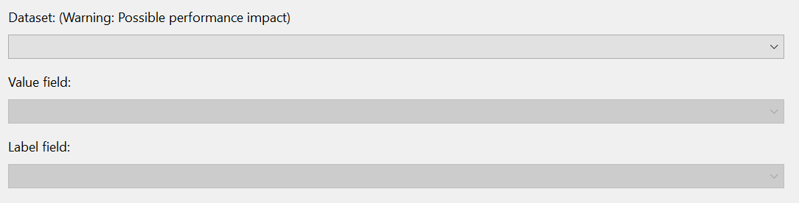

You now have two options: to attach a new dataset to this parameter, or to delete the parameter entirely.

- If you plan to attach a new dataset to this parameter, follow the steps provided above.
- If you plan to delete the parameter, follow the guidance in the how-to manage parameters document (tbc).

Close the Report Parameter Properties window when you are finished and enter CTRL+S to save your changes to the .RDL file.

 | You will need to repeat this process for every “Dependent Item” linked to the shared dataset you are retiring. Every .RDL file which you amend will need to be republished with a new version number following the steps in the HOW TO - Manage Reports - Release and Deployment.docx

Remove the dataset from HR Reporting
Go back to the Home → Datasets (MASTER) within the HR Reporting environment from which you want to remove the shared dataset. Select your dataset to be taken to its Properties page, and at the top of the screen, click the “Delete” button:

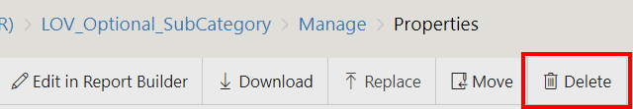

A warning message will pop-up. Click “Delete”.

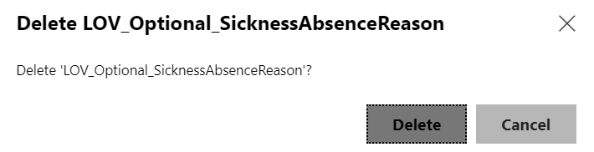

Your screen will refresh and you will be returned to the Datasets (MASTER) folder.

